To: Dan Austin  
From: Stuart McGorman  
Date: Feb 4 2025  
RE: GISC 480 Lab #3

Purpose

This memo will discuss the methods and results of the impact assessment preformed for the proposed road project north west of Kelowna BC (Figure 1). This includes a baseline assessment which establishes the existing ecosystems in the study area (Figure 2) as well an impact assessment which analyzes the impact on ecosystem areas caused by the proposed project footprint and right of way (Figure 3, Table 1) – specifically regarding the habitats for the Painted Turtle and the Townsend’s Big-eared Bat (Tables 2,3,4,5).

Summary  
The purpose of this study is to analyze and quantify the environmental impact of the proposed road project. The specifications of the proposed project we’re provided via a CAD file which was used to determine the study area and impact polygons. The existing ecosystem areas in the study area were defined using a provided BC SEI (sensitive ecosystems Inventory) TEM (Terrestrial Ecosystem Mapping) layer which was manually edited to include account for the existing road. The proposed impact areas and ecosystem areas were then compared to determine the extent and classification of impacted habitat. The impacted ecosystem areas where then compared with a provided WHR (Wild Habitat Rating) table to determine the impact to Painted Turtle and Townsend’s Big-Eared Bat’s specifically

Methods

To perform the analysis the provided CAD file was first imported and georeferenced using BC parcels data. The study area was then defined by generating a 500m buffer around the centerline of the proposed road. The polygons for the proposed footprint and right of way were also accessed defined according to the CAD file. The existing ecosystem areas in the study area were defined using a provided BC SEI (sensitive ecosystems Inventory) TEM (Terrestrial Ecosystem Mapping) layer which was clipped to the study area. The SITE_MC_S1 (Site Series Map Code Component 1) attribute was used to classify ecosystem areas. The existing road was also manually clipped out from the SEI-TEM layer using satellite imagery and the area of the existing road was classified using the code RZ. An intersect was then used to combine the data between the ecosystem areas and the impact areas. The resultant table was then joined with the provided WHR table and exported to excel where several pivot tables could be created to summarize the results

Results / Discussion

With the analysis complete the results were summarized in as shown in Figures 1-5. Figure 1 summarizes the total area of each ecosystem classification which will be impacted by the proposed project. Of the 2265579m^2 in the study area (Figure 2), 93220m^2 will be impacted by the footprint and 84956m^2 will be impacted by the right of way (Figure 3). Figure 1 also shows that PF, PT, RO, SO, And SP are the Ecosystem classification codes that will have the most area Impacted by the project. Figures 2 and 3 show the area of high and moderately rated habitat which will be impacted for the Painted Turtle while Figures 4 and 5 show the area of high and moderately rated habitat which will be impacted for the Townsend’s Big Eared bat. For both species the habitat area impacted by both the footprint and right of way are relatively small portions of the total habitat area in the study area.



Table 1: Impacted Ecosystem Areas



Table 2: RCROR_LIS (Painted Turtle – Living, Summer) Habitat Impact



Table 3: RCROR_STILA (Painted Turtle - Security/Thermal & Living, All Seasons) Habitat Impact



Table 4: MCOTO_FDLIG (Townsend's Big Eared Bat - Food & Living, Growing (Spring, Summer, Fall) Habitat Impact



Table 5: MCOTO_STLIG (Townsend's Big Eared Bat – Security/Thermal & Living, Growing [Spring, Summer, Fall]) Habitat Impact

Conclusions / Recommendations

The summarized data as well as the maps provided (Figures 1,2,3) should be further analysed by wildlife experts to inform decisions regarding the proposed road project.

References:  
All data provided by Dan Austin as part of the Lab 3 data package for GISC480 at the University of British Columbia, January 2025

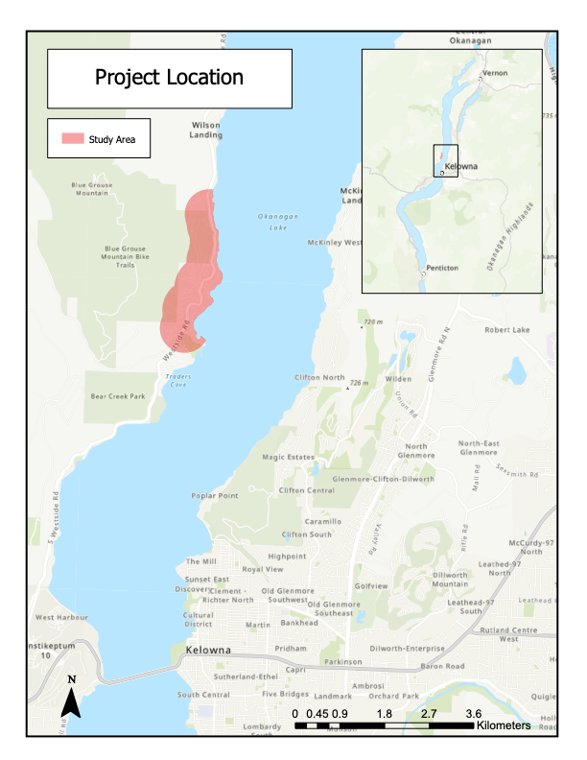

Figure 1: Project Location



Figure 2: Study Area

Figure 3: Proposed Impact